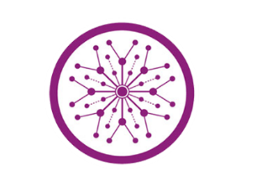

**The Superior University Lahore**

**Faculty of Computer Science & Information**

**Technology**

**Name: Alishba Haroon**

**Roll No: BSAI-116-4C**

**Date: 27 March 2025**

**Subject: PAI LAB**

**Task 12**

**CyberGruad Information**

1. **Imports and Setup**



* + **Flask:** A web framework for Python to build web applications. It is used to handle routes and requests in the app.
  + **render_template:** Renders HTML templates on the frontend (UI).
  + request: Used to get data from the client-side (like user input in the chat).
  + **jsonify:** Converts the Python object into a JSON response that is sent back to the client.
  + **pipeline:** This is a utility from the Hugging Face Transformers library to easily load pre-trained models and use them for tasks like text generation.

1. **Flask App Initialization**



* This initializes a Flask app with the __name__ variable. This is necessary for Flask to identify the application.

1. **Load the GPT-2 Model**

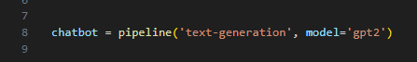

* 'text-generation' is the task the model is being used for.
* 'gpt2' is the name of the model being loaded. GPT-2 is a transformer-based model known for generating human-like text based on a given input prompt.

1. **Home Route**

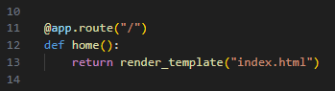

* This is a simple route (/) for the home page. When a user visits the root URL (/), Flask will render the index.html template. This is where the chatbot interface will be shown.

1. **Generating Responses Using GPT-2**

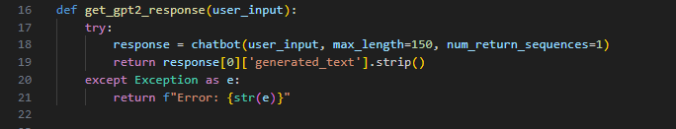

* + The user_input is passed to the model, and chatbot(user_input) generates a response.
  + max_length=150: Limits the response to 150 tokens/words.
  + num_return_sequences=1: Tells the model to return only one response.
  + The response from the GPT-2 model is a list of generated text, and response[0]['generated_text'] fetches the generated text from the first response.
  + If an error occurs, the except block catches it and returns a string with the error message.

1. **Route for Chatbot Communication**

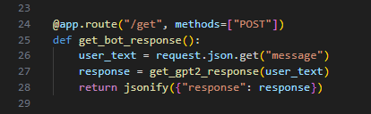

* + **Method:** POST is used because the client will send data (the user's message) to the server.
  + **request.json.get("message"):** Extracts the user input (the message) from the incoming JSON request.
  + **get_gpt2_response(user_text):** Calls the function to get a response from the GPT-2 model.
  + **jsonify({"response": response}):** Returns the model's response as a JSON object. This is the response that will be sent back to the client.

1. **Running the Flask App**



* + **if name == "main":** This ensures that the Flask app runs only when the script is executed directly, not when it is imported as a module.
  + **app.run(debug=True):** Starts the Flask web server in debug mode. This mode allows you to see detailed error messages and auto-reloads the server when code changes are made.

**OUTPUT:**

